EETC-2361
Lab #3
Calibration - Temperature

Purpose:

The purpose of this laboratory experiment is to introduce the student to calibration principles using the Resistance Temperature Detector and Thermocouple. The student will calculate loop parameters and calibrate a transmitter with a resistance input (RTD) & a Thermocouple input to produce an industry standard 4-20mA current output.

Background:

Calibrating instruments is the responsibility of a technician. This process requires the technician to be familiar with how to use calibration equipment, such as input simulators, multi-meter, transducers, and transmitters. Input simulator is required to simulate the process measurement, which is typically sensed by a transducer. Input simulators vary according to the type of measurement. For example, a pressure transmitter requires a simulator that can generate a pressure signal within the range of the transmitter. In this lab, temperature will be used as a measurement, so the input simulator will need to generate a signal compatible with the temperature measuring device. The multi-meter is required to measure the output signal. Typically, the output signal will be a current signal in the range of 4mA to 20mA. This device must be accurate to within the accuracy of the transmitter output signal. The device being calibrated is known as a transmitter, which processes the input signal and converts the signal to a standard current signal.

When calibrating an instrument, a technician must be capable of identifying the relationship between the input and output. This can typically be done by using simple algebra. In fact, most devices are linear, so a typical approach is to apply the y-intercept formula, y = mx + b, where y is the output signal, x is the input signal, m is the slope of the line and b is where the line intersects with the y-axis. The following steps will outline a technique for finding this equation:
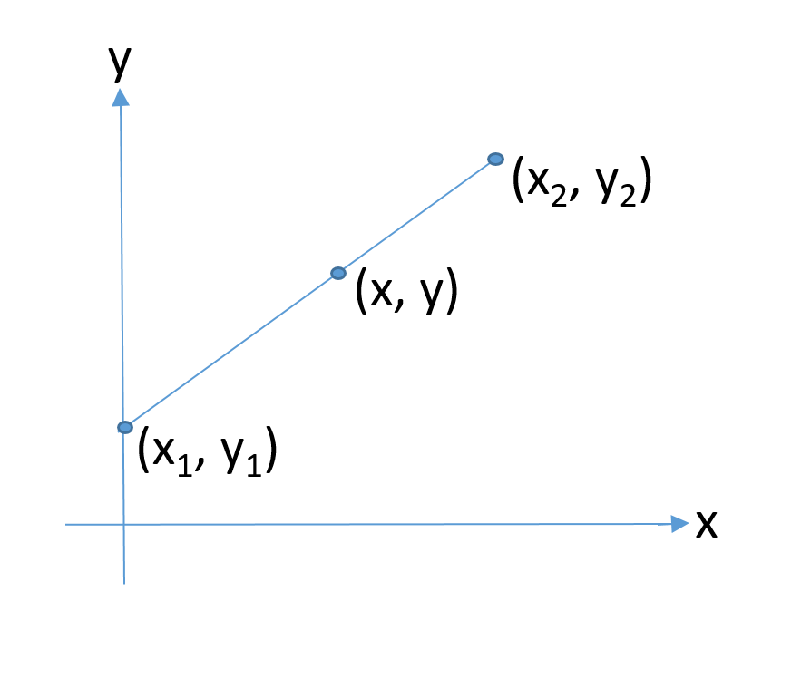
- Identify the range of the input signal and output signal:
  - Input: x₁ – x₂, (An example of a temperature range is 0-400ºF)
  - Output: y₁ – y₂, (typically 4mA – 20mA)
  - Sketch a plot of these on an x-y graph as shown.
- Find the slope of the line:
  - m = (y₂ – y₁) / (x₂ – x₁) = constant
- Use the slope equation again, this time replace x₂ & y₂ with the variables x & y, which are arbitrary points on the line. Also, this new slope calculation must also equal the constant found in step 2. Remember the slope must apply to any point on the line:
  - m = (y – y₁) / (x – x₁) = constant
- Rearrange the resulting equation:
  - (y – y₁) = constant * (x – x₁)
  - (y – y₁) = constant * x – constant * x₁
  - y = constant * x – constant * x₁ + y₁
  - y = constant * x – (constant * x₁ - y₁)
- An example follows using the values in step 1:
  - m = (20mA – 4mA) / (400 ºF - 0 ºF) = 0.04 mA/ ºF
  - m = (y – 4mA) / (x – 0ºF) = 0.04 mA/ ºF
  - (y – 4mA) = 0.04 mA/ ºF * (x – 0ºF)
  - (y – 4mA) = (0.04 mA/ ºF) * x
  - y = (0.04 mA/ ºF) * x + 4mA
  - [y = 0.04 * x + 4 ] mA

Temperature is one of the most basic industrial measurements. Temperature measurement is required in applications such as furnaces, boilers, heat exchangers, process heating systems, compressor bearing temperature, and many others. There are several types of devices that can be used for measuring temperature; however, the two devices that will be the focus of this laboratory experiment is the Resistance Temperature Detector and the Thermocouple.

The Resistance Temperature Detector, or RTD, is essentially a platinum rod and has a resistance of 100Ω at 0ºC. The platinum has a positive temperature coefficient so the resistance will increase proportionally as the temperature increases. There are other material types and resistance values for an RTD, but the platinum is the most popular. The platinum RTD is useful in temperature ranges below 1000ºF.

The Thermocouple is composed of two dissimilar wires that are bonded together at one end. The thermocouple will generate a small voltage (in the milli-volt range) between the two wires that is proportional to the temperature at the tip. Thermocouples are simple devices that can be used over a wide range of temperatures. The temperature range of interest will determine the “type” of thermocouple that is required. This laboratory experiment will use a type J thermocouple which is constructed of iron and constantan (a copper-nickel alloy), which is accurate up to about 1400ºF. The RTD and T/C are shown connected to a transmitter in an instrument loop below.

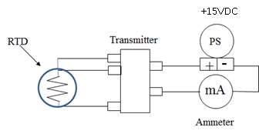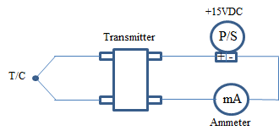

Figure #1 – RTD & T/C Temperature Instrument Loops

Procedure:

Initial Calculations (10%)
- Knowing that the input range of a transmitter is 0-200ºF and the output range is 4-20mA:
  - Create a calibration Curve equation for the relationship between temperature an current, i.e., y = mx + b as shown in the lab background material above.
  - Calculate the output current for the input conditions shown below:

Temperature Calculations
Temperature | Current (mA)
0ºF | 4 mA
50ºF | 8 mA
100ºF | 12 mA
150ºF | 16 mA
200ºF | 20 mA

Resistance Temperature Detector (RTD) (25%)

- Set up the T287 transmitter using the T287 Configurator found in the Action T287 folder. [HV-found in eetlabsoft(\\pstcc9)(L:)] [BC-found on Laptops] Connect the T287 to the computer using the cable provided. Upload the data from the transmitter to the program. If the program does not read the transmitter change the COM port under Options/Communication. Refer to figures #2 & #3, configure the transmitter for a 0-200ºF input range. To change the Sensor Type, the Select Sensor button brings up screen 2 where the tabs at the top are used to select between T/C, RTD, etc. Set up the transmitter as a 3-wire connection and a 100Ω platinum (0.00385) RTD input. Download the settings to the transmitter. Disconnect the transmitter from the computer.

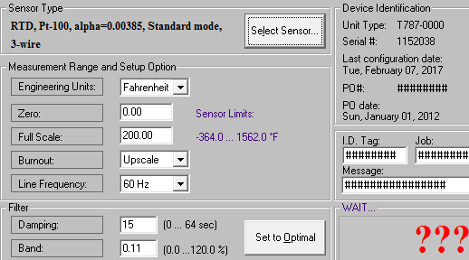
Figure #2 – T287 Configurator Screen 1

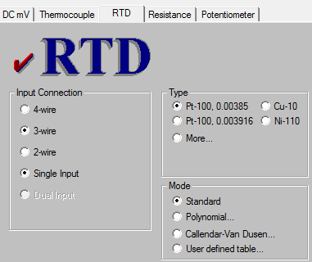
Figure #3 – T287 Configurator Screen 2

- Referring to figure #4, use the T287 transmitter with a 3-wire RTD calibrated input signal from the Fluke 724 Temperature Calibrator which will also serve as the power supply and ammeter during the lab. For the instrument loop, connect the bottom right side of the Fluke 724 to the transmitter (724 LOOP Red to #5 on the T287 and 724 LOOP Black common to #6 on the T287). For calibrating the transmitter for the RTD, connect the SOURCE side of the Fluke 724 to the transmitter (724 SOURCE Red (RTD) to #2 on the T287 and 724 SOURCE Black common to #3 and #4 on the T287).

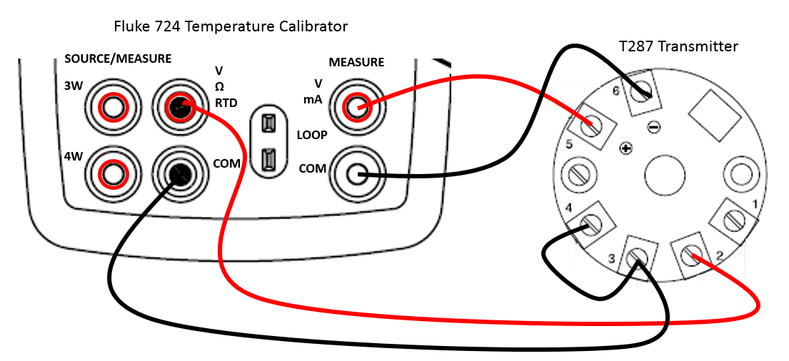
Figure #4 – Transmitter Calibration Connections for the RTD

- Turn on the Fluke 724 Temperature Calibrator, press so that the calibrator reads MEASURE LOOP on the top readout, then press 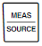 until the calibrator reads SOURCE on the lower readout. Press so that the lower readout is reading °F. Then press until the lower readout shows Pt100. At 0%, the lower readout should be 0 °F and at 100% it should read 200 °F. If not, the numbers can be adjusted using the blue arrows and then holding down the 0% or 100% appropriately. Test the transmitter with a five-point check and record the mA reading from the upper readout on the Fluke 724.

RTD Calibration
Temperature | Current (mA)
0ºF
50ºF
100ºF
150ºF
200ºF

- Measure the resistance of a 3-wire RTD at room temperature and record both the resistance and temperature readings.

RTD Measurements
Resistance | Temperature ºF (Thermometer) | Temperature ºC

- Instrument loop connections remain the same and the Fluke 724 stays in LOOP mode. Referring to figure #5, remove the input calibrator connections on the T287and replace it with a 3-wire RTD (2 wires of the same color go to #3 and #4 and the other wire goes to #2).

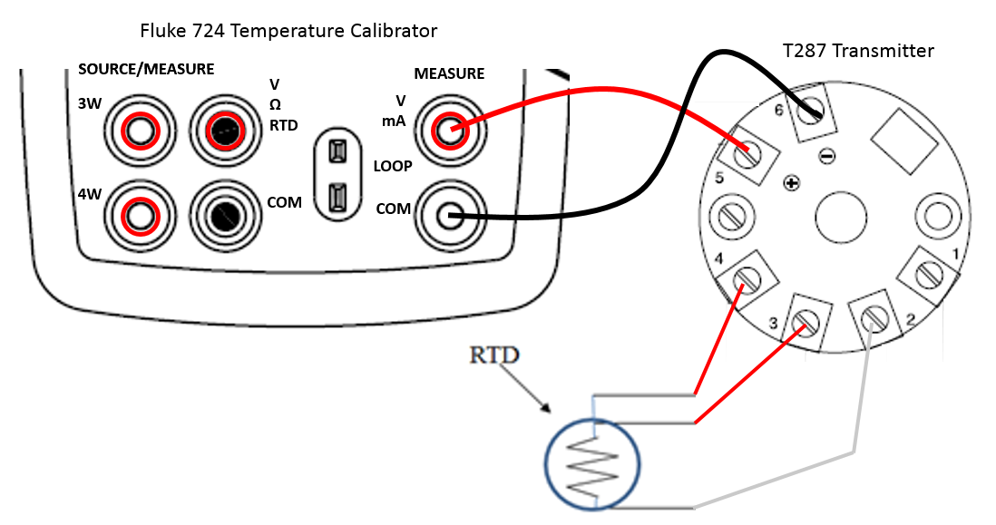
Figure #5 – RTD Measurement Connections

- Take a room temperature reading & record your results. Use two cups of water (one cold and the other hot) and measure the temperature using the RTD sensor and a comparison thermometer. Record the mA current reading and the thermometer reading. Compute the calculated temperature from the Current reading using the following equation: .
RTD Measurements for T287
Sample | Current Output  (mA) | Temp ºF  (Calculated) | Temp ºF  (Thermometer)
Cold Sample
Room Temperature
Hot Sample

Calculate the errors indicated below:
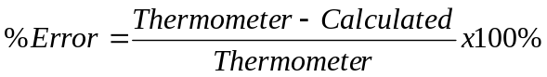

RTD Error Calculations for T287
Sample | Error  (Thermometer & Calculated)
Cold Sample
Room Temperature
Hot Sample

Thermocouple (25%)

- Set up the T287 transmitter using the T287 Configurator found in the Action T287 folder. [HV-found in eetlabsoft(\\pstcc9)(L:)] [BC-found on Laptops] Connect the T287 to the computer using the cable provided. Upload the data from the transmitter to the program. If the program does not read the transmitter change the COM port under Options/Communication. Refer to figures #6 & #7, configure the transmitter for a 0-200ºF input range. To change the Sensor Type, the Select Sensor button brings up screen 2 where the tabs at the top are used to select between T/C, RTD, etc. Set up the transmitter as a Type J Thermocouple input. Download the settings to the transmitter. Disconnect the transmitter from the computer.

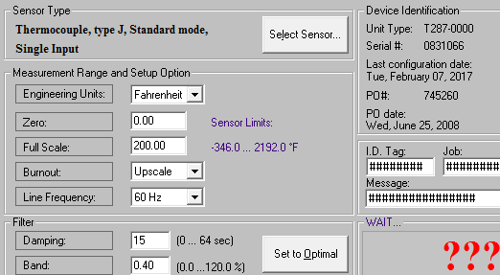
Figure #6 – T287 Configurator Screen 1

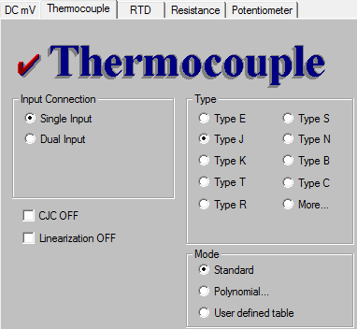
Figure #7 – T287 Configurator Screen 2

- Referring to figure #8, use the T287 transmitter with a Type J Thermocouple calibrated input signal from the Fluke 724 Temperature Calibrator which will also serve as the power supply and ammeter during the transmitter calibration. For the instrument loop, connect the bottom right side of the Fluke 724 to the transmitter (724 LOOP Red to #5 on the T287 and 724 LOOP Black common to #6 on the T287). For calibrating the transmitter for a Thermocouple, connect the Thermocouple adapter connection to the Fluke 724 (Notice the connections are different sizes so be sure it is turned the correct way). The wires from this connection are connected to the transmitter (Red wire to #2 on the T287 and White wire to #3 on the T287).
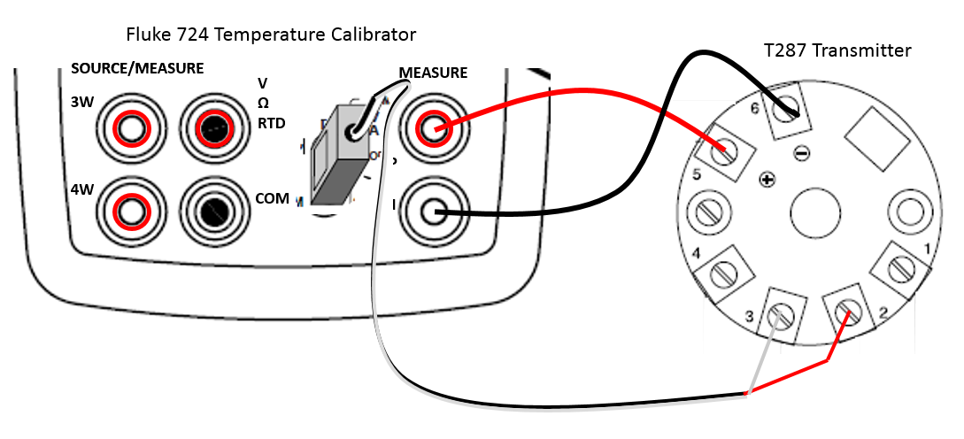
Figure #8 – Transmitter Calibration Connections for the T/C

- Turn on the Fluke 724 Temperature Calibrator, press so that the calibrator reads MEASURE LOOP on the top readout, then press until the calibrator reads SOURCE on the lower readout. Press so that the lower readout is reading °F. Then press until the lower readout shows J. At 0%, the lower readout should be 0 °F and at 100% it should read 200 °F. If not, the numbers can be adjusted using the blue arrows and then holding down the 0% or 100% appropriately. Test the transmitter with a five-point check and record the mA reading from the upper readout on the Fluke 724.

T/C Calibration
Temperature | Current (mA)
0ºF
50ºF
100ºF
150ºF
200ºF

- Set the input calibrator to the maximum temperature of 200ºF so that the loop current is at a maximum value of 20mA. Using a 1k potentiometer, add resistance in series with the power supply and transmitter while measuring the voltage across the transmitter. Record the voltage across the output terminals of the transmitter when the circuit current just begins to drop This point indicates that the transmitter has reached the minimum operating voltage. This is the actual minimum operating voltage.

T/C Measurements
Minimum Operating Voltage

- Instrument loop connections remain the same and the Fluke 724 stays in LOOP mode. Referring to figure #9, remove the input calibrator connections on the T287 and replace it with a Type J T/C (Red wire to #2 and White wire goes to #3).
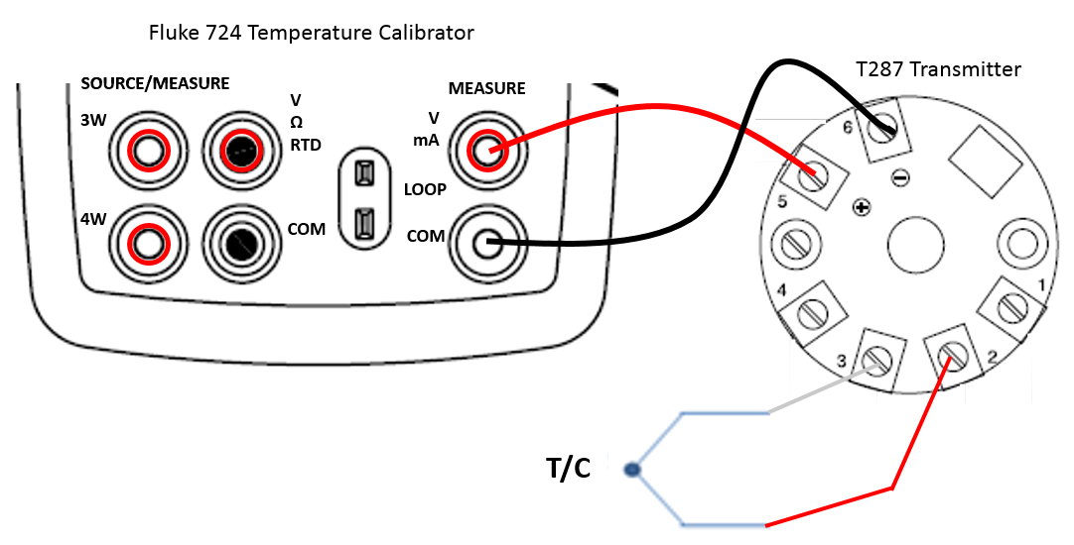
Figure #9 – T/C Measurement Connections

- Take a room temperature reading & record your results. Use two cups of water (one cold and the other hot) and measure the temperature using the T/C sensor and a comparison thermometer. Record the mA current reading and the thermometer reading. Compute the calculated temperature from the Current reading using the following equation: .

T/C Measurements for T287
Sample | Current Output  (mA) | Temp ºF  (Calculated) | Temp ºF  (Thermometer)
Cold Sample
Room Temperature
Hot Sample

Calculate the errors indicated below:

T/C Error Calculations for T287
Sample | Error  (Thermometer & Calculated)
Cold Sample
Room Temperature
Hot Sample

Questions (40%):

- Referring to the minimum operating voltage found in step #11, how does this value compare to the transmitter specifications? (Transmitter specifications can be found on D2L/Content/Labs below Lab #5 called Transpak_T287.)

- Use the measured minimum operating voltage and assume this transmitter is installed in an instrument loop with a 24VDC power supply. What is the maximum loop resistance that the device can drive?

- Assuming a temperature coefficient of 0.385Ω/ºC, compute the resistance of an RTD at the room temperature measured in step #5. How does this result compare to that measured in step #5? What are some possible reasons for any deviation?

- How do the error calculations of the RTD and T/C compare? (see tables in step #7 & 13)?

